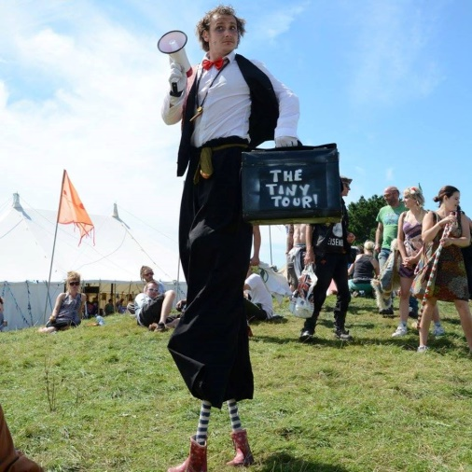
Ross Wheeler
BA Honours Street Arts
Creator, Performer and Facilitator of Artistic Works
rosswheeler.biz@gmail.com 07765935574

Co-Founder and Co-Artistic Director:
www.hotchpotchperformance.co.uk
Online Portfolios: www.rosswheeler.weebly.com
Project Director: www.thecrookedthicket.co.uk

Personal Statement
I am passionate about outdoor arts and working with communities to deliver work that engages people in new enjoyable or inspiring creative experiences. I am interested cross-pollination between the arts and welcome any new or familiar experiences whilst continuing to develop my own unique practice.
Main Skills
- Circus & Street Theatre- Stilt Walking, Fire Performance, Animation and Walkabout, Storytelling
- Workshop Facilitator- Ground Based Circus Skills, Expert Stilt Walking & Prop Spinning, Making Workshops with Resourced Material
- Directing- Fire Circus Director/Choreographer, Group Walkabouts, Interactive Street Theatre
- Project Management- Fundraising, Book Keeping, General Admin, Project Planning, Business Networking, Social Media, Risk Assessment
- Crew Coordinator- General Organisation, Programming, Communications & Relevant Admin
Hotch Potch Performance
I am a self-employed Co-Artistic Director and Company Manager of Hotch Potch, a performance company specialised in outdoor arts 2011-Present, first formed in Hampshire and then based in Cornwall, UK 2012-present.
Circus Workshop Facilitator
Camel Circus Jams with Project Paul CIC: Project Delivery with Circus Workshops in hard to reach areas, March 2017-Present.
Camborne Circus Jams: Town Council and admission funded Family Workshops and Shared Practice Space, Project Manager and Deliverer, on and off 2013-Present,
Circus with Different Abilities: Working with different events in the South West and Cornwall’s Accessible Activities Programme in delivering performances, interactive sensory circus installations and workshops 2015-17.
Hotch Potch Circus Workshops: Leading general ground based circus workshops, prop making as well prop expert tuition of prop spinning and stilt walking to performers and events 2012-Present

Commissions
The sTEAm Party: Project Manager and Deliverer and Street Performance Coordinator of FEAST funded family area and works across Camborne Trevithick Day 2017.
The Littlemotive: Working with Interplay to create and perform a child ridden miniature locomotive with lighting effects and displays across Wadebridge Bikelights and other Cornish events Winter 2016.
Café Petite: Arts Council funded tour of a miniature storytelling café experience, Project/Tour Manager, Co-Director and Performer in 2014’s tour or South West based events and Shambala Festival.

Other Works
The Tiny Tour: Self-Funded one-man family show with storytelling, stilt walking and installations across natural spaces 2016-Present. Performed at festivals and events in the South West including Somerfest Outdoor Arts Festival and the upcoming Arts and Culture Weekend at The Eden Project.
Stilt Walking: An extensive list of comedy solo walkabouts across the South West and beyond 2006-Present, directing group walkabouts & performing a recent solo stilt dancing stage act.
Hotch Potch Fire Arts: Main Performer, Director and Choreographer of solo and group fire shows across the South West and beyond 2011-Present.
Ka-Dunk-A-Junk: Group Promenade Junk Tribe of Rhythmic Outsiders, Co-Director and Performer, Larmer Tree Festival, Hat Fair, UK 2011. Saisbury’s Student Olympic Games, Boom Town Festival, Hat Fair, UK & De La Scene, La Rue est a Amiens, France 2012.
Flexi-La-Flem: An 80’s power ballad inspired, out of shade aerobics troupe, in slow-motion. Co-Director and Performer, Larmer Tree Festival, London Olympic Games, UK, 2012.
Crew Coordinator: Outsourcing and coordinating street shows, walkabouts and workshops for events across Cornwall 2013-Present.
Dr Strangelove’s Burlesque Discotheque: Co-Directors and Performer of a weekly cabaret at The Railway Pub 2011-12, Hampshire, UK and a one-off special at De La Scene, Arras, France 2012.
Other Works Outside of Hotch Potch
The Crooked Thicket: Project Director including all managerial roles; Fundraiser, Outreach Officer, Site Manager, Crowdfunding Campaign Manager & Winner of Start-up Funds and Place on The Lloyds Bank Social Entrepreneurs Programme.
The project facilitated outreach event The Secret Cabaret and co-managed Camborne Circus Jams in 2014, before running a programme of events and workshops to help artists and therapists on-site over 2016.
Swamp Circus: Performer 2005-2009 at various South West events as well as Belfast Circus’ Youth Circus Exchange/Showcase & The London Roundhouse’s Youth Circus Conference in 2005.

Qualifications
Bachelor of Arts Honours Degree: Street Arts
Studying a broad range of outdoor arts and performance with John Lee, Dr. Olu Taiwo and guest tutors, with workshops from companies such as; Wildworks, Desperate Men, Wet Picnic, Handspring Puppet Company, Fuse Performance, Spymonkey, Mimbre and a residency from Periplum in creating “Subverse” at Gosport Submarine Museum 2010.
The degree also lead to other opportunities outside the course such as performing in No Fit State Circus’ Parklive, Taunton 2010, Dot Comedy’s The Chain, Hat Fair 2012 & a week long residency with Kamchatka, leading to a one off performance through the University of Winchester 2014.
BTEC National Diploma: Performing Arts
AS GCE: Photography
ABC Level 3 Award: Single Camera Program Making
Level 2 Award: Food Safety in Catering
NCFE’s: Circus Arts L2, Drugs Awareness L1
NOCN Award: Self Employment L2
GCSEs: English, Mathematics, Statistics, ICT, Double Art and Design

Other Certificates and Training
Enhanced DBS Certificate
First Aid: Outdoor First Aid Certificate, valid until Oct 2017.
Certificate of Fellowship: Lloyds Bank Social Entrepreneurs Programme 2013-14, at the Cornwall School for Social Entrepreneurs.
Sous Chef: Six years’ experience working in kitchens leading to a Sous Chef Position at St James Tavern, Winchester, Jul-Dec 2012. Creating & budgeting dishes, food orders, training staff, running the kitchen during head chef’s absence.
Site Manager: Self-taught site manager of a two acre family small holding 2013-present, gardening, forestry, building, project planning, accounts and financial reports.

References are available upon request

